**1** Define strategy.

Strategy specifies how an organization matches its own capabilities with the opportunities in the marketplace to accomplish its objectives.

**2** What are four key perspectives in the balanced scorecard?

The four key perspectives in the balanced scorecard are (1) Financial perspective—this perspective evaluates the profitability of the strategy and the creation of shareholder value; (2) Customer perspective—this perspective identifies the targeted customer and market segments and measures the company’s success in these segments; (3) Internal business process perspective—this perspective focuses on internal operations that further both the customer perspective by creating value for customers and the financial perspective by increasing shareholder value; and (4) Learning and growth perspective—this perspective identifies the capabilities at which the organization must excel to achieve superior internal processes that create value for customers and shareholders.

**3** Describe three features of a good balanced scorecard.

A good balanced scorecard design has several features:

1. It tells the story of a company’s strategy by articulating a sequence of cause-and-effect relationships.

2. It helps to communicate the strategy to all members of the organization by translating the strategy into a coherent and linked set of understandable and measurable operational targets.

3. It places strong emphasis on financial objectives and measures in for-profit companies. Nonfinancial measures are regarded as part of a program to achieve future financial performance.

4. It limits the number of measures to only those that are critical to the implementation of strategy.

5. It highlights suboptimal trade-offs that managers may make when they fail to consider operational and financial measures together.

**4** What are three important pitfalls to avoid when implementing a balanced scorecard?

Pitfalls to avoid when implementing a balanced scorecard are the following:

1. Don’t assume the cause-and-effect linkages are precise; they are merely hypotheses. An organization must gather evidence of these linkages over time.

2. Don’t seek improvements across all of the measures all of the time.

3. Don’t use only objective measures in the balanced scorecard.

4. Don’t fail to consider both costs and benefits of different initiatives before including these initiatives in the balanced scorecard.

5. Don’t ignore nonfinancial measures when evaluating managers and employees.

**5** Why is it important to distinguish between the performance of a manager and the performance of the organization subunit for which the manager is responsible? Give an example.

There are many acceptable answers. Here is one I came up with:

In some cases, the subunit’s performance may not be a good indicator of a manager’s performance. For example, companies often put the most skillful division manager in charge of the weakest division in an attempt to improve the performance of the weak division. Such an effort may yield results in years, not months. The division may continue to perform poorly with respect to other divisions of the company. But it would be a mistake to conclude from the poor performance of the division that the manager is performing poorly.

**6** “Managers should be rewarded only on the basis of their performance measures. They should be paid no salary.” Do you agree? Explain.

No, rewarding managers on the basis of their performance measures only, such as ROI, subjects them to uncontrollable risk because managers’ performance measures are also affected by random factors over which they have no control. A manager may put in a great deal of effort but her performance measure may not reflect this effort if it is negatively affected by various random factors. Thus, when managers are compensated on the basis of performance measures, they will need to be compensated for taking on extra risk. Therefore, when performance-based incentives are used, they are generally more costly to the owner. The motivation for having some salary and some performance-based bonus in compensation arrangements is to balance the benefits of incentives against the extra costs of imposing uncontrollable risk on the manager.

**7**  Explain the incentive problems that can arise when employees must perform multiple tasks as part of their jobs.

When employees have to perform multiple tasks as part of their jobs, incentive problems can arise when one task is easy to monitor and measure while the other task is more difficult to evaluate. Employers want employees to intelligently allocate time and effort among various tasks. If, however, employees are rewarded on the basis of the task that is more easily measured, they will tend to focus their efforts on that task and ignore the others.

**8** Strategy, balanced scorecard, merchandising operation.

XYZ company buys T-shirts in bulk, applies its own trendsetting silk-screen designs, and then sells the T-shirts to a number of retailers. The company wants to be known for its trendsetting designs, and it wants every teenager to be seen in a distinctive XYZ T-shirt. The company presents the following data for its first two years of operations:

Year 1 Year 2

Number of T-shirts purchased 215,000 245,000

Number of T-shirts discarded 15,000 20,000

Number of T-shirts sold (row 1 minus row 2) 200,000 225,000

Average selling price $30 $31

Average cost per T-shirt $15 $13

Administrative capacity (number of customers) 4,500 4,250

Administrative costs $1,633,500 $1,593,750

Administrative cost per customer (row 7 / row 8) $363 $375

Administrative costs depend on the number of customers XYZ has created capacity to support, not on the actual number of customers served. XYZ had 3,600 customers in Year 1 and 3,500 customers in Year 2.

Required:

**1.** Is XYZ’s strategy one of product differentiation or cost leadership? Explain briefly.

**2.** Describe briefly the key measures XYZ should include in its balanced scorecard and the reasons for doing so.

**SOLUTION**

1. XYZ follows a product differentiation strategy. XYZ’s designs are “trendsetting,” its T-shirts are distinctive, and it aims to make its T-shirts a “must have” for each and every teenager. These are all clear signs of a product differentiation strategy, and to succeed, XYZ must continue to innovate and be able to charge a premium price for its product.

2. Possible key elements of XYZ’s balance scorecard, given its product differentiation strategy:

*Financial Perspective*

(1) Increase in operating income from charging higher margins, (2) price premium earned on products

These measures will indicate whether XYZ has been able to charge premium prices and achieve operating income increases through product differentiation.

*Customer Perspective*

(1) Market share in distinctive, name-brand T-shirts, (2) customer satisfaction ratings, (3) number of new customers, (4) number of mentions of XYZ’s T-shirts in social media posts.

XYZ’s strategy should result in improvements in these customer measures that help evaluate whether XYZ’s product differentiation strategy is succeeding with its customers. These measures are, in turn, leading indicators of superior financial performance.

*Internal Business Process Perspective*

(1) Quality of silk-screening (number of colors, use of glitter, durability of the design), (2) frequency of new designs, (3) time between concept and delivery of design

Improvements in these measures are expected to result in more distinctive and trendsetting designs delivered to its customers and in turn, superior financial performance.

*Learning and Growth Perspective*

(1) Ability to attract and retain talented designers (2) improvements in silk-screening processes, (3) days of continuous education and marketing and sales staff at different skill levels, (4) employee satisfaction ratings

Improvements in these measures are expected to improve XYZ’s capabilities to produce distinctive designs that have a cause-and-effect relationship with improvements in internal business processes, which in turn lead to customer satisfaction and financial performance.

**9** Strategy, balanced scorecard, service company.

RST is an architectural firm that has been in practice only a few years. Because it is a relatively new firm, the market for the firm’s services is very competitive. To compete successfully, RST must deliver quality services at a low cost. RST presents the following data for its first two years of operations:

Year 1 Year 2

Number of jobs billed 40 50

Selling price per job $32,000 $30,000

Architect labor hours 24,000 27,000

Cost per architect labor hour $35 $36

Architect support capacity (number of jobs the firm can do) 60 60

Total cost of software-implementation support $168,500 $180,000

Software-implement. support capacity cost per job (row6/row5) $2,800 $3,000

Architect labor-hour costs are variable costs. Architect support costs for each year depend on the Architect support capacity that RST chooses to maintain each year (that is, the number of jobs it can do each year). Architect support costs do not vary with the actual number of jobs done that year.

(Please note that Architect support costs are in the form of Software-implementation support and are used interchangeably in the problem.)

Required:

**1.** Is RST’s strategy one of product differentiation or cost leadership? Explain briefly.

**2.** Describe key measures you would include in RST’s balanced scorecard and your reasons for doing so.

**SOLUTION**

1. RST’ strategy in Year 2 is cost leadership. RST’s architectural services are not distinct from its competitors. The market for these services is very competitive. To succeed, RST must deliver quality service at low cost while improving productivity.

2. Balanced Scorecard measures for Year 2 follow:

*Financial Perspective*

(1) Increase operating income from productivity gains and growth, (2) revenues per employee, (3) cost reductions in key areas, for example, architect and software-implementation support

These measures indicate whether RST has been able to reduce costs and achieve operating income increases through cost leadership.

*Customer Perspective*

(1) Market share, (2) number of new customers, (3) customer responsiveness index, (4) customer satisfaction index

RST’s strategy should result in improvements in these customer measures that help evaluate whether RST’s cost leadership strategy is succeeding with its customers. These measures are leading indicators of superior financial performance.

*Internal Business Process Perspective*

(1) Time to complete customer jobs, (2) time lost due to errors, (3) quality of job (are the architectural designs what the customer wanted?)

Improvements in these measures are key drivers of achieving cost leadership and are expected to lead to more satisfied customers, lower costs, and superior financial performance.

*Learning and Growth Perspective*

(1) Time required to analyze and design steps, (2) time taken to perform key steps in the design process, (3) skill levels of employees, (4) hours of employee training, (5) employee satisfaction and motivation

Improvements in these measures are likely to improve RST’s ability to achieve cost leadership and have a cause-and-effect relationship with improvements in internal business processes, customer satisfaction, and financial performance.

**10** Balanced scorecard.

Following is a random-order listing of perspectives, strategic objectives, and performance measures for the balanced scorecard.

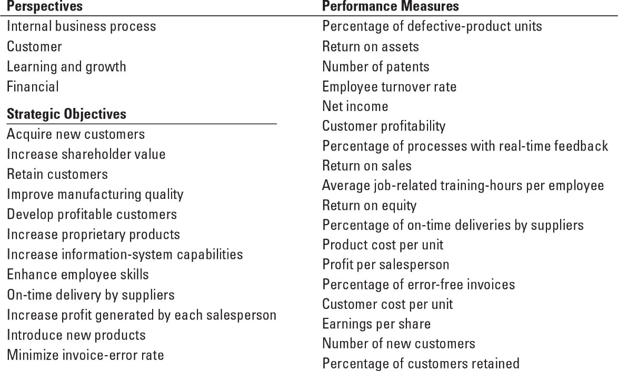

Required:

For each perspective, select those strategic objectives from the list that best relate to it. For each strategic objective, select the most appropriate performance measure(s) from the list.

Edit by Brian Lendecky – ignore the strategic objectives. For each of the four perspectives, select the most appropriate performance measure(s) from the list.

**SOLUTION**

#### Strategic Performance

**Perspectives Objectives Measures**

▪ Financial ▪ Increase shareholder value ▪ Earnings per share

# ▪ Net income

# ▪ Return on assets

▪ Return on sales

▪ Return on equity

▪ Product cost per unit

▪ Increase profit generated ▪ Profit per salesperson

by each salesperson

▪ Customer ▪ Acquire new customers ▪ Number of new customers

▪ Retain customers ▪ Percentage of customers retained

▪ Develop profitable customers ▪ Customer profitability

▪ Customer cost per unit

▪ Internal Business ▪ Improve manufacturing ▪ Percentage of defective

Process quality product units

▪ Introduction of new products ▪ Number of new products

▪ Minimize invoice error rate ▪ Percentage of error-free invoices

▪ On-time delivery by suppliers ▪ Percentage of on-time deliveries

by suppliers

▪ Increase proprietary products ▪ Number of patents

▪ Learning and ▪ Increase information system ▪ Percentage of processes with

Growth capabilities real-time feedback

▪ Enhance employee skills ▪ Employee turnover rate

▪ Average job-related training

hours per employee

**11**  Balanced scorecard.

Dunder Mifflin, a division of Sabre Corp., manufactures various types of color laser printers in a highly automated facility with high fixed costs. The market for laser printers is competitive. The various color laser printers on the market are comparable in terms of features and price. Michael Scott, the regional manager, believes that satisfying customers with products of high quality at low costs is important to achieving its target profitability. For the year, Michael plans to achieve higher quality and lower costs by improving yields and reducing defects in its manufacturing operations. Michael will train workers and encourage and empower them to take the necessary actions. Currently, a significant amount of Dunder Mifflin’s capacity is used to produce products that are defective and cannot be sold. Michael expects that higher yields will reduce the capacity that Dunder Mifflin needs to manufacture products. Michael does not anticipate that improving manufacturing will automatically lead to lower costs because many costs are fixed costs. To reduce fixed costs per unit, Michael could lay off employees and sell equipment, or Dunder Mifflin could use the capacity to produce and sell more of its current products or improved models of its current products.

Dunder Mifflin’s balanced scorecard (initiatives omitted) for the just-completed fiscal year follows:

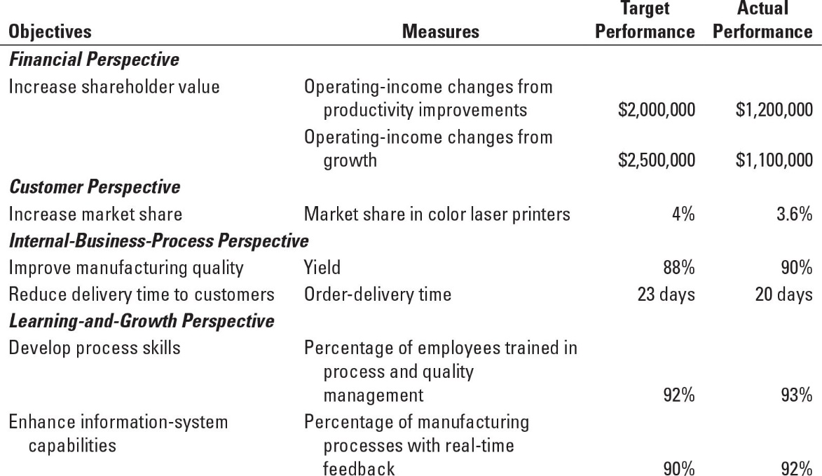

Required:

**1.** Was Dunder Mifflin successful in implementing its strategy this year? Explain.

**2.** Is Dunder Mifflin’s balanced scorecard useful in helping the company understand why it did not reach its target market share this year? If it is, explain why. If it is not, explain what other measures you might want to add under the customer perspective and why.

**3.** Would you have included some measure of employee satisfaction in the learning-and-growth perspective and new-product development in the internal-business-process perspective? That is, do you think employee satisfaction and development of new products are critical for Dunder Mifflin to implement its strategy? Why or why not? Explain briefly.

**4.** What problems, if any, do you see in Dunder Mifflin improving quality and significantly downsizing to eliminate unused capacity?

**SOLUTION**

1. The market for color laser printers is competitive. Dunder Mifflin’s strategy is to produce and sell high-quality laser printers at a low cost. The key to achieving higher quality is reducing defects in its manufacturing operations. The key to managing costs is dealing with the high fixed costs of Dunder Mifflin’s automated manufacturing facility. To reduce costs per unit, Dunder Mifflin would have to either produce more units or eliminate excess capacity.

The scorecard correctly measures and evaluates Dunder Mifflin’s broad strategy of growth through productivity gains and cost leadership. There are some deficiencies, of course, that subsequent assignment questions will consider.

It appears from the scorecard that Dunder Mifflin was not successful in implementing its strategy this year. Although it achieved targeted performance in the learning and growth and internal business process perspectives, it significantly missed its targets in the customer and financial perspectives. Dunder Mifflin has not had the success it targeted in the market and has not been able to reduce fixed costs.

2. Dunder Mifflin’s scorecard does not provide any explanation of why the target market share was not met this year. Was it due to poor quality? Higher prices? Poor post-sales service? Inadequate supply of products? Poor distribution? Aggressive competitors? The scorecard is not helpful for understanding the reasons underlying the poor market share.

Michael Scott may want to include some measures in the customer perspective (and internal business process perspective) that get at these issues. These measures would then serve as leading indicators (based on cause-and-effect relationships) for lower market share. For example, Dunder Mifflin should measure customer satisfaction with its printers on various dimensions of product features, quality, price, service, and availability. It should measure how well its printers match up against other color laser printers on the market. This is critical information for Dunder Mifflin to successfully implement its strategy.

3. Michael Scott should include a measure of employee satisfaction to the learning and growth perspective and a measure of new product development to the internal business process perspective. The focus of its current scorecard measures is on processes and not on people and products.

Michael considers training and empowering workers as important for implementing Dunder Mifflin’s high-quality, low-cost strategy. Therefore employee training and employee satisfaction should appear in the learning and growth perspective of the scorecard. Dunder Mifflin can then evaluate if improving employee-related measures results in improved internal-business process measures, market share and financial performance.

Adding new product development measures to internal business processes is also important. As Dunder Mifflin reduces defects, theirs costs will not automatically decrease because many of Dunder Mifflin’s costs are fixed. Instead, Dunder Mifflin will have more capacity available to it. The key question is how Dunder Mifflin will obtain value from this capacity. One important way is to use the capacity to produce and sell new models of its products. Of course if this strategy is to work, Dunder Mifflin must develop new products at the same time that it is improving quality. Hence, the scorecard should contain some measure to monitor progress in new product development. Improving quality without developing and selling new products (or downsizing) will result in weak financial performance. The new product development need not focus on designing innovative products that can command a price premium because Dunder Mifflin’s strategy is one of cost leadership and not product differentiation but rather on product extensions that could help it grow sales.

4. Improving quality and significantly downsizing to eliminate unused capacity is difficult. Recall that the key to improving quality at Dunder Mifflin is training and empowering workers. As quality improvements occur, capacity will be freed up, but because costs are fixed, quality improvements will not automatically lead to lower costs. To reduce costs, Michael Scott must take actions such as selling equipment and laying off employees. But how can management lay off the very employees whose hard work and skills led to improved quality? If it did lay off employees now, will the remaining employees ever work hard to improve quality in the future? For these reasons, Michael Scott should first focus on using the newly available capacity to sell more products. If he cannot do so and must downsize, Dunder Mifflin should try to downsize in a way that would not hurt employee morale, such as through retirements and voluntary severance.

If it had to downsize, the preferred approach for Dunder Mifflin to follow is to first downsize by laying off employees, assure the remaining employees that there will be no more layoffs, and then seek to improve quality.

**12** **Executive compensation, balanced scorecard.**

A company recently introduced a new bonus plan for its corporate executives. The company believes that current profitability and customer satisfaction levels are equally important to the company’s long-term success. As a result, the new plan awards a bonus equal to 0.5% of salary for each 1% increase in business unit net income or 1% increase in the business unit’s customer satisfaction index. For example, increasing net income from $1 million to $1.1 million (or 10% from its initial value) leads to a bonus of 5% of salary, while increasing the business unit’s customer satisfaction index from 50 to 60 (or 20% from its initial value) leads to a bonus of 10% of salary. There is no bonus penalty when net income or customer satisfaction declines. In Year 1 and Year 2, the company’s three business units reported the following performance results:

|  | Retail Sales | | Online Sales | | Wholesale Sales | |
| --- | --- | --- | --- | --- | --- | --- |
|  | Yr 1 | Yr 2 | Yr 1 | Yr 2 | Yr 1 | Yr 2 |
| Net income | $730,000 | $811,900 | $1,218,000 | $1,557,479 | $1,062,540 | $1,108,123 |
| Customer satisfaction | 87 | 93 | 78.3 | 75 | 65.7 | 72.9 |

The percentage changes in net income and customer satisfaction in the three business units between Year 1 and Year 2 are as follows:

|  |  |  |  |
| --- | --- | --- | --- |
|  | **Retail Sales** | **Online Sales** | **Wholesale**  **Sales** |
| Percentage change in net income  ($ 811,900 − $ 730,000) ÷ $ 730,000;  ($1,557,479 − $1,218,000) ÷ $1,218,000;  ($1,108,123 − $1,062,540) ÷ $1,062,540 | 11.22% | 27.87% | 4.29% |
| Percentage change in customer satisfaction  (93 − 87) ÷ 87; (75 – 78.3) ÷ 78.3; (72.9 – 65.7) ÷ 65.7 | 6.90% | (4.21%) | 10.96% |

The bonus formula indicates that the executives of the three units will receive the following Year 2 bonuses as a percent of salary:

Retail Sales: 11.22% + 6.9% = 18.12% × 0.5 = 9.06% of salary

Online Sales: 27.87% + 0% = 27.87% × 0.5 = 13.94% of salary

Wholesale Sales: 4.29% + 10.96% = 15.25% × 0.5 = 7.63% of salary

Required:

**1.** What factors might explain the differences between improvement rates for net income and those for customer satisfaction in the three units? Are increases in customer satisfaction likely to result in increased net income right away?

**2.** The company’s board of directors is concerned that the Year 2 bonus awards may not accurately reflect the executives’ overall performance. In particular, the board is concerned that executives can earn large bonuses by doing well on one performance dimension but underperforming on the other. What changes can it make to the bonus plan to prevent this from happening in the future? Explain briefly.

**SOLUTION**

1. The results show an inverse relation between changes in net income and changes in customer satisfaction. When changes in net income are higher, changes in customer satisfaction are lower, and vice versa. Some units, such as Wholesale Sales, may be over-investing in customer satisfaction initiatives, causing overall financial performance to decline. However, increases in customer satisfaction are not likely to pay off as immediately as increases in net income, which suggests that these units may be making investments in customer satisfaction to increase long-term financial performance, even though these investments cause short-term net income to decline. On the other hand, Online Sales appears to be harvesting income today at the expense of future net income; the decline in customer satisfaction scores is troubling and does not bode well for financial performance in upcoming years. The company needs to examine whether one or both of these explanations is true.

2. The board of directors can set targets for changes in both net income and customer satisfaction. This would allow the company to take differences in the units, their competitive environments, and their customers into account when assessing performance. Target setting would also allow the company to reward managers when desirable investments in one dimension lead to short-term declines in the other.

In addition, the board can improve the bonus plan by determining the relative importance of short-term changes in net income and customer satisfaction. Currently, a 1% change in either measure receives the same weight in the bonus formula, and declines have no effect on bonus payouts. Online Sales, for example, receives no penalty for producing lower customer satisfaction scores. Moreover, a 1% increase in one measure may be more valuable than a 1% increase in the other, and declines in either measure may have a bigger effect on long-term value than increases. The payment formula can be modified by putting appropriate (and different) weights on each of these factors.